Title or Task: | Enhancing your first Web Site  

Description:
Files Required | Computer with Dreamweaver or similar
Suitable for Classes: | AIT • Multimedia • Cert II IT • Cert II Bus
Area: | Technology & Enterprise
Teacher: | Mr Peter Faulks
Timeline | 2 lessons

Date Due:
Task Brief: | Create a web site with links & graphics
Outcomes: | Create pages for school topics

Items highlighted in yellow are tasks for you to complete
Items in Blue italic are help tips
You should have a site folder (MySite) and a page called index.html
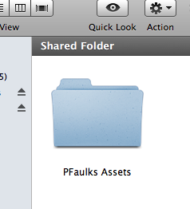


This is lesson 2
Task Brief – Rationale:
You will now create your own Personal Web Site which will include
- Your name (index.html) - (splash page)
- Some text about you in various styles and colours about.html
- A picture of yourself
- Your favorite sport, pop star or subject favourite.html
- Some pictures of your pet or family or friends
- A page about your school school.html
- A page covering your own topic.html

Open the web site you created in ADW100 Dreamweaver setting a site

Also open the ADW101 Data Files.zip file

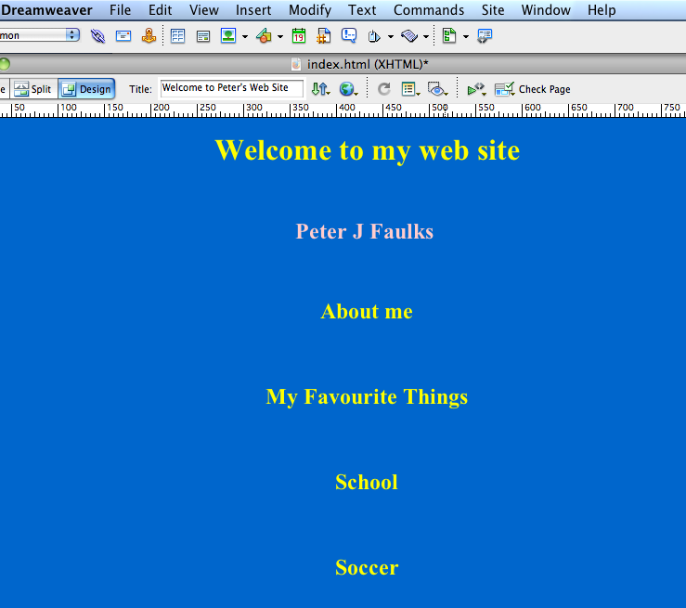

We now need to create more pages for our site, we will do this by using existing page (index.html) and changing the colour, and title and use SaveAs to create a new page :- these will be

index * about * favourites * school * topic (and any topic you choose).

Create a personal web page containing five pages linked together.

Page 1 (index.html) a Welcome Page

QUIZ (index.html also known as a_________ page)

Page 2 about.html All about you
Page 3 favourites.html favourite pastime or things you like to do
Page 4 school.html Your school, a timetable or assignments
Page 5 topic.html Any topic of interest
Open Dreamweaver and click on Manage Site, find your folder called MySite and click Done
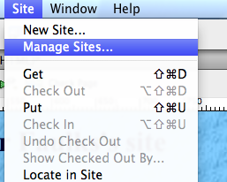
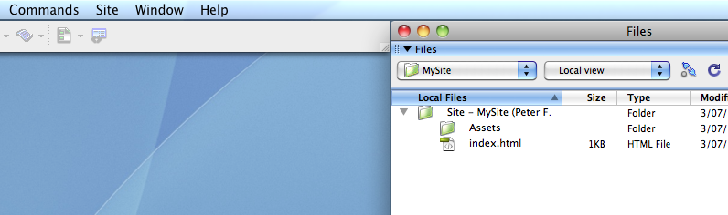

Open the page index.html (double click from the files list)

It should look something like this (with your colours) - on the right are the files
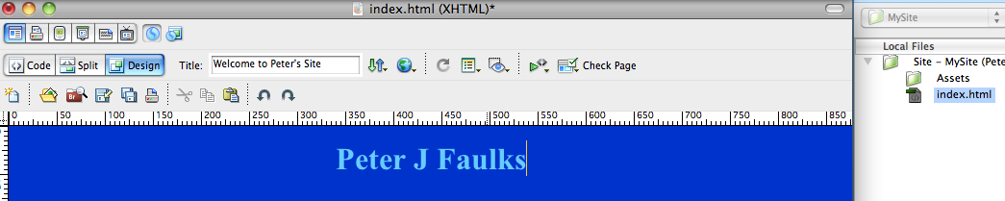

Change the title to Welcome to (Your name’s) website

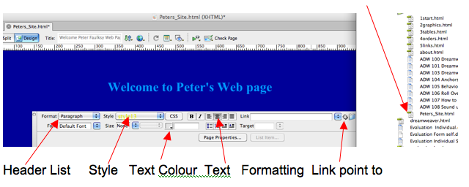

Now we are going to make more pages changing the text then use Save As to create new pages

Change the header Welcome to ??? to About Me Page
Change the title to About Me

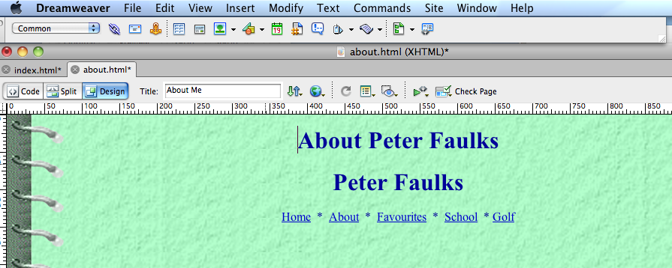

Creating page 2 (about.html)
Open Page properties and click on Background image: Browse for a Background image and find the graphic BackgroundBinderTrans.png
click OK

Change the colour and click Apply to find one you like.
Change the background colour (Page Properties)
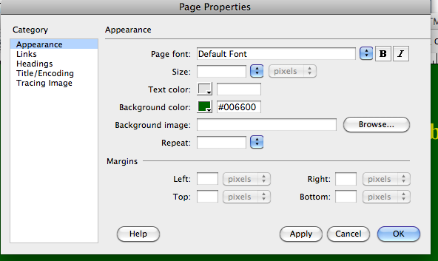
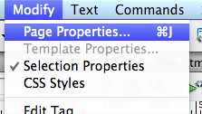

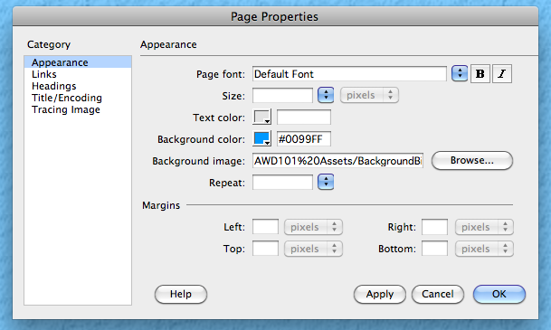

On the index.html page we now need to save as a different file…

Click on SaveAs and save this page as about.html

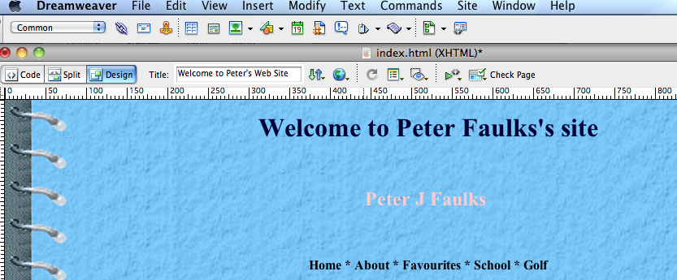

Add a photograph of yourself - (take a photo or find one you like) make the photo about 10 cm x 10cm and 72dpi and click on Insert - Image
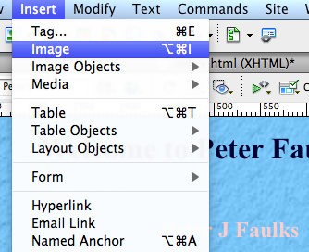

Find the photo and insert it onto your page.

You will be asked to save the photo so save it to your Assets folder inside MySite folder and then give it a name in the Alt Window.

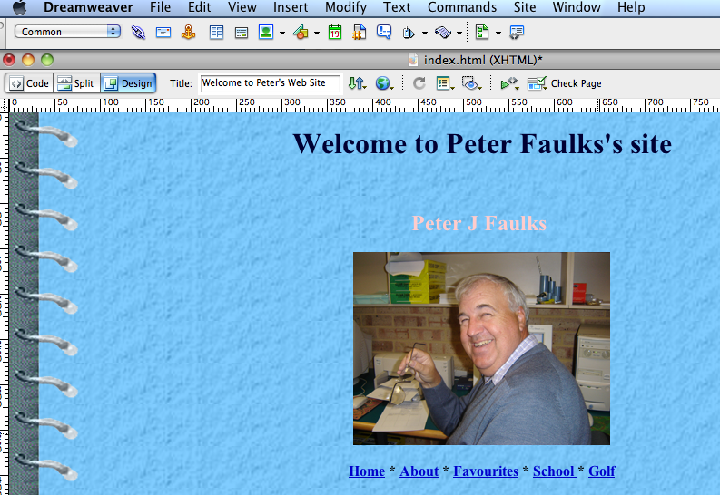

Put an image on each site centered under your links

You may be asked to give the image a name – do so in the image tag

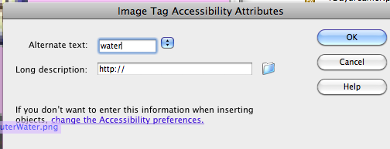

If you have a photograph of yourself put this onto your about page.

Save your work.

Add some text to each page covering the topic or title of the page and then we will add some images

Images

On each page add a different image, on about.html page put a picture of yourself

From the AWD101 Assets zip find an appropriate file or

Copy the images below and put them into your Assets folder

Images you can use save as .jpg files or Right click and save as .png


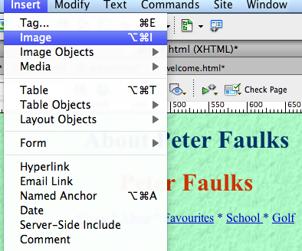

Browse to an image from your folder and click insert, center or place the image (give the image a name in the ALT Window)

Note: If the image is outside of your folder you will be asked to copy it there:- put it into the Assets folder

and move on to the next page save each page

Got to File Save As…

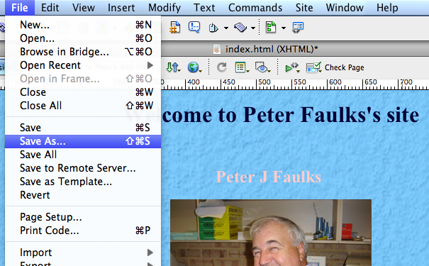

Save the page as about.html to your folder

Now we can make Page 3 (favourites)
Change all the colours and titles and them SaveAs

Page 3 On the about.html page, open Properties window change the background image (the graphic BackgroundBinderTrans.png) and change the colour for a Favourites Page

Change the background colour (Page Properties)
Change the title ???’s to My Favourites Page
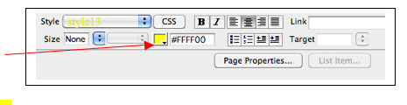

Change the font colour
To change the colour of the font Properties
Window)

Change the header to Favourites
Remove the photo and add a different photo or image
Got to File Save As…

Save this page as favourites.html

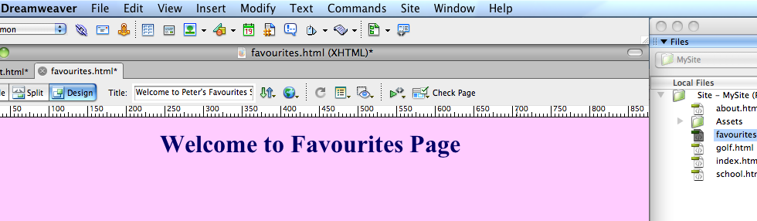

Page 4 (School Page) Change the background colour (Page Properties)
Add a background image, (use the graphic BackgroundBinderTrans.png) or make a background image of your own.
Change the title to Welcome to ???’s School Page
Change the header About to Welcome to My School Page
Change the font colour
Insert an image

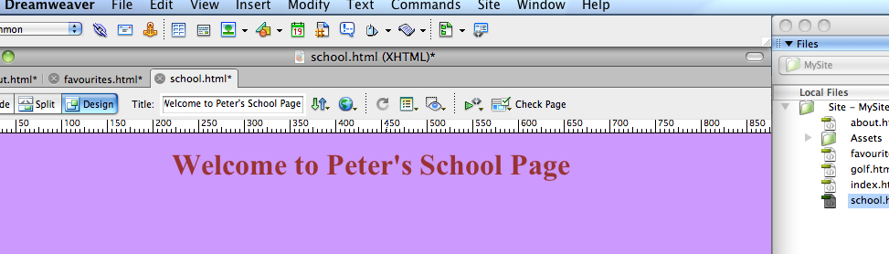

Got to File Save As…

Save this page as school.html

Save as school.html to your folder

Page 5 Repeat as previously (Any Topic) Change the background colour (Page Properties) , add a background image.
Change the title to Topic (you may have a known topic – i.e. My Friends)
Change the header to your Topic (recipes, soccer, netball, TV whatever interests you).
If you need help just ask

Insert an image
Change the font colour

5. Save this page as topic.html (my topic is Golf)

Save as topic.html

You should now have five pages. Insert a screen shot of your pages below:-

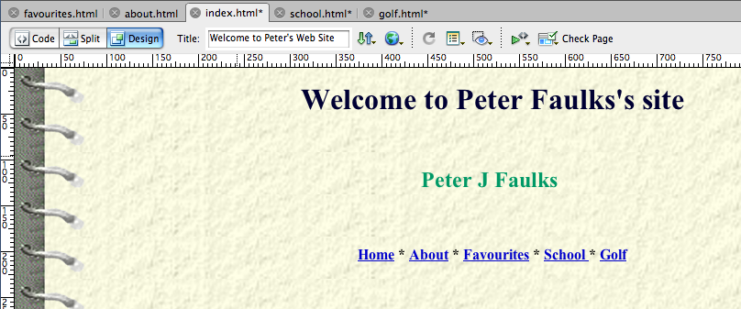 Index.html

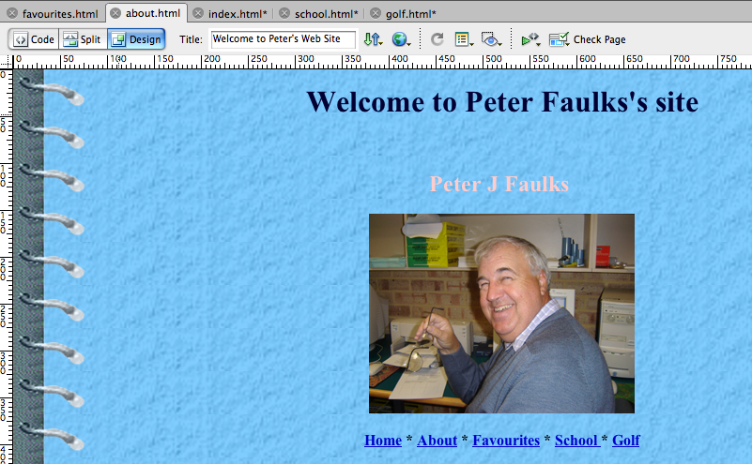 about.html

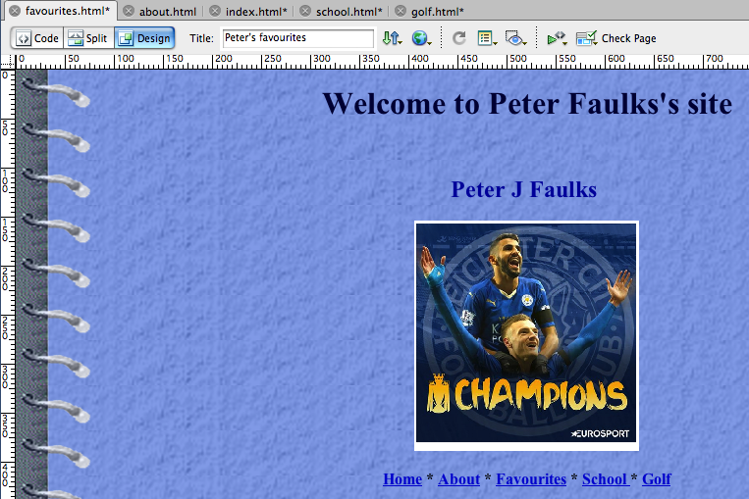 favourites.html

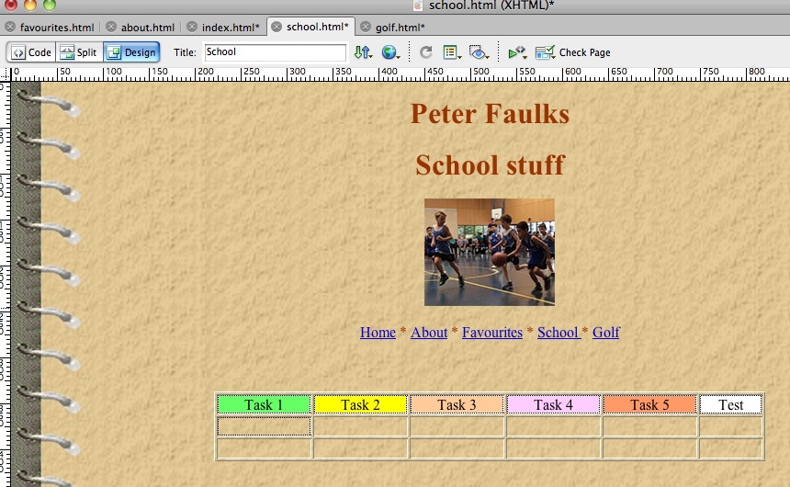 school.html

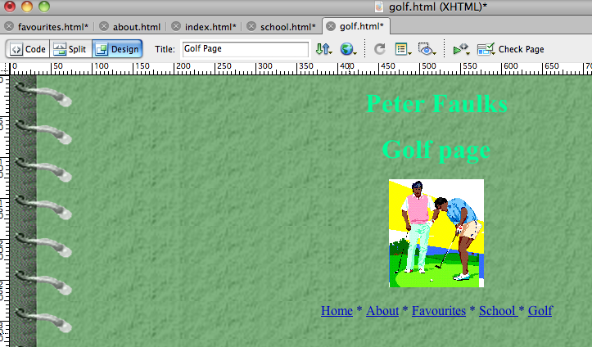 golf.html (topic)

Now we will make or check the links on each page

Open the index.html page

Now we will make simple links to each page

On the index.html page Type Home * About * Favourites * School * Topic

Use the Askerisk as a break between each title (Shift 8)

Center this on the page then Highlight Home
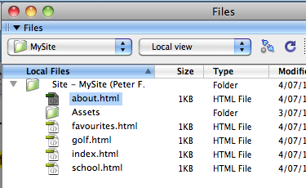
Home * About * Favourites * School * Topic

Then link this to your home (index) page (see below)

Use the point to file linker (click and drag to index.html)

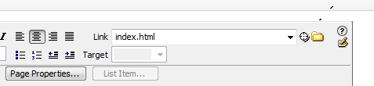

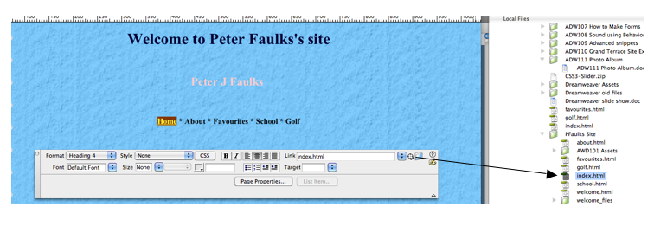

Repeat this to link every page highlighting each page name and point to each page with the file pointer (drag it to the page).
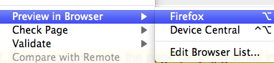

You now have links to every page

Copy the text to each page then save all pages and test your links in Preview in Browser Click the world icon or go to File – Preview in Browser and select a browser.

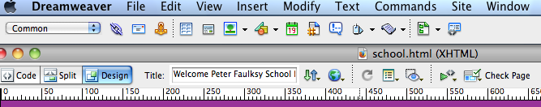
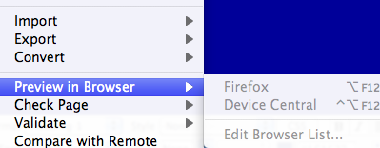

Home * About * Favourites * School * Topic

Did all the links work on EVERY PAGE?

Yes but if your links have a dark look on the page change to Page Properties and background colour to make my page look better.

Tip: Keep your background pages light in colour to enhance text or take a look at WBQ101 Web Quest Design Principles.doc help you manage colours.

Having got all the links we can now copy them onto each page

Highlight all the links and click copy


Open each page and replace the row of page names with the linked row press paste on each page
Save all pages

If the links look too dark modify all your pages so you can see the links, and your name.

Test your site in the browser.

We need to add an email contact so friends can contact us
The code for email is


mailto:yourname@aserver.com.au

Type Please email me: and insert the image email_rotating.gif

Then highlight the text Please E-Mail me

and in Link type mailto:yourname@emailaddress.com

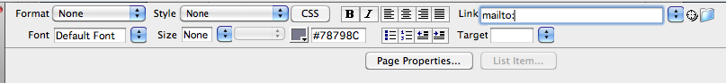
(mailto:)
Replacing the details to suit

Save all the pages

This ends this session



You have made your first web page and now your first web site

Move onto the next Exersize (lesson 3), adding links, tables, anchors and buttons.

